Memorandum of Understanding
,
This Memorandum of Understanding is between the Delaware County Probate/JuvenileCourt ("Court") and the Big Walnut Local School District ("BWLSD") as a means of defining the limited relationship shared with regard to the School Liaison Program ("SLP") .

Offer
  - The Court shall provide service through the SLP Program for the 2019-2020 school academic school year.

Acceptance
  - By making the financial contribution listed below, the BWLSD fully accepts the terms of this MOU, based on the offer, consideration and other items listed in this Memorandum of Understanding.

Consideration
  - The Court shall provide the following:
    - A Court employee who shall be bound by all county policies and shall provide all services incumbent upon the SLP;
    - Office space, mileage reimbursement, electronic and technological requirements for the execution of the job duties required by the SLP.
    - Other incidental provisions that will assist the SLP program that are normal and appropriate for the effectuation of the purpose of the SLP.

  - The BWLSD shall provide the following:
    - Financial contribution of ten thousand dollars ($10,000) to the SLP.
    - Access to attendance logs/software, meeting rooms (when required and available), access to students and staff during the school day.
    - Other incidental provisions that will assist the SLP program that are normal and appropriate for the effectuation of the purpose of the SLP.

Type of MOU
      - The SLP shall serve as an independent contractor to the BWLSD, and the BWLSD shall not be responsible for and disclaim any contribution to OPERS pursuant to R.C. §145 et. seq., or any other obligation than that of the amount specified in Section 3.b.l., identified above in this MOU. The Court shall assume all OPERS contributions, if any, on behalf of the SLP.

Insurance and Indemnification
      - Each Party shall carry and maintain throughout the life of the MOU such general liability and vehicle insurance as will protect it and the Parties against any and all claims for personal injury, including death, loss of moneys/funds, or property damage, which may arise out of or result from the performance of or operations under this MOU or from the use of any vehicle(s) in connection therewith, and shall include coverage for indemnification as described above.

Prior to commencement of this MOU, each Party shall present to the other current certificates of insurance and shall maintain current, without lapse, such insurance during and throughout the entire term of this MOU. Said insurance shall, at a minimum, be of a type which is customary in the industry or is required by law, whichever is the greater standard. Such insurance shall provide coverage in an amount that is both standard in the industry and adequate to protect each Party and the Indemnified Parties against any and all liability or damages arising from the Services provided under the MOU. Each Party shall be responsible for any and all premiums for such policy(ies).

Worker's Compensation
      - Each Party shall, as applicable, carry and maintain, throughout the life of this MOU, Worker's Compensation Insurance as required by Ohio law and any other state in which work will be performed. Each Party shall be responsible for any and all premiums for such policy(ies). At any time throughout the life of the MOU either Party may request proof of such insurance. Proof of such insurance shall be promptly provided upon request.

Drug Free Environments
      - The Court and BWLSD agree to comply with all applicable state and federal laws regarding drug-free environments and shall have established and have in place a drug free workplace policy. Each Party shall make a good faith effort to ensure that all of its employees will not purchase, use, or possess illegal drugs or alcohol or abuse prescription drugs in any way.

Competitive Bidding - Not Required
      - Consistent with R.C. §307.86 and the requirements therein, this MOU is not required to be competitively bid.

Drafting
      - This MOU shall be deemed to have been drafted by both Parties and no purposes of interpretation shall be made to the contrary.

Signatures
      - Any person executing this MOU in a representative capacity hereby warrants that he/she has authority to sign this MOU or has been duly authorized by his/her principal to execute this MOU on such principal's behalf and is authorized to bind such principal.

Entire Agreement
      - This MOU shall constitute the entire understanding and agreement between the Parties, shall supersede all prior understandings and agreements, whether written or oral, between the Parties relating to the subject matter hereof, and may only be amended in writing with the mutual consent and agreement of the Parties.

SIGNATURES

Angie Pollock, Superintendent Date

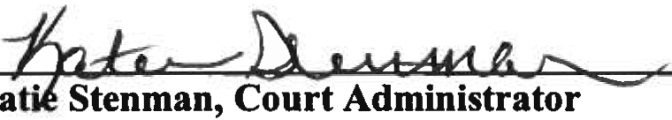
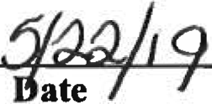

Page 2 of 2

